* Method Pemberitahuan update

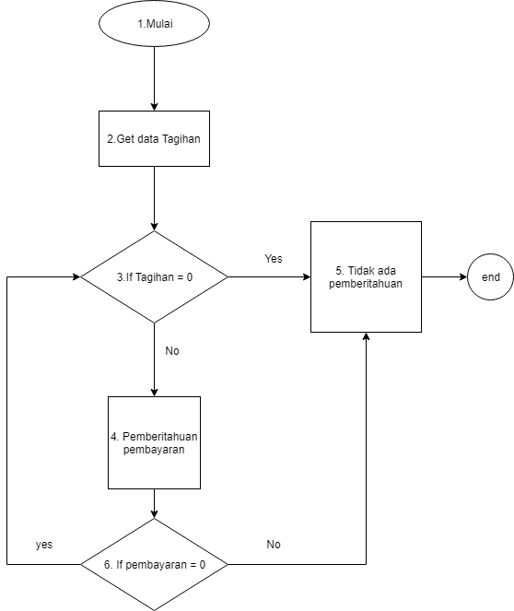

V(G) = 2 +1 = 3

Path 1 = 1-2-3-5

Path 2 = 1-2-3-4-6-5

Path 3 = 1-2-3-4-6-3-5

* Method input data

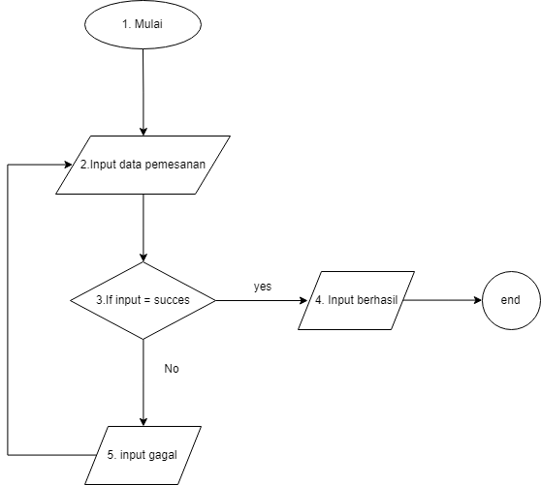

V(G) = 1 +1 = 2

Path 1 = 1-2-3-4

Path 2 = 1-2-3-5-2-4

* Method jadwal bis

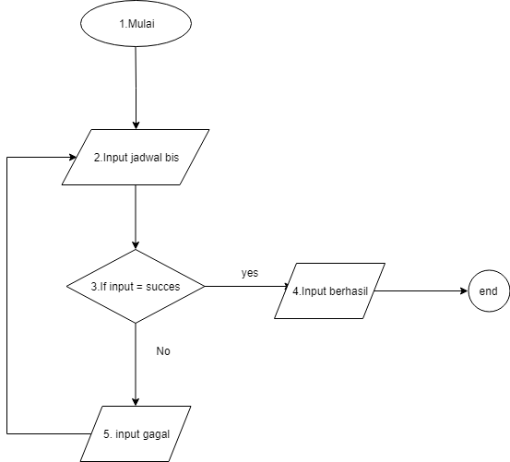

V(G) = 1 +1 = 2

Path 1 = 1-2-3-4

Path 2 = 1-2-3-5-2-4

* Method Simpan Data

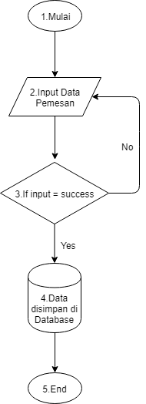

V(G) = 1 +1 = 2

Path 1 = 1-2-3-4

Path 2 = 1-2-3-2-3-4

* Update Data

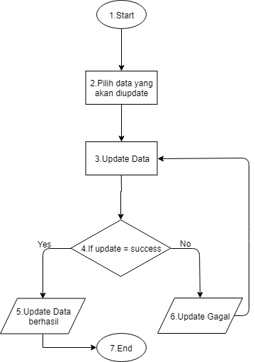

V(G) = 1 +1 = 2

Path 1 = 1-2-3-4-5

Path 2 = 1-2-3-4-6-3-4-5

* Data Tagihan

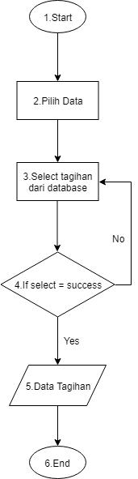

V(G) = 1 +1 = 2

Path 1 = 1-2-3-4-5

Path 2 = 1-2-3-4-3-4-5